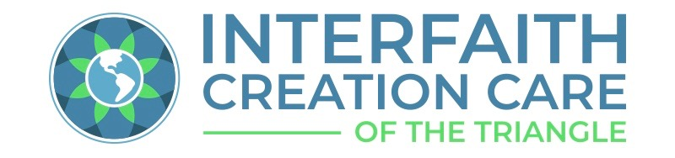

Position on Composting Policy
Interfaith Creation Care of the Triangle: A Network of 80 Faith Communities
March 29, 2022
As part of their sacred duty to care for Creation, many people of faith and many faith communities are already composting, using backyard methods, community sites, and/or large scale commercial composting operations.
Unfortunately, the bulk of food waste (96% according to Paul Hawken’s 2021 book, Regeneration) and much yard waste wind up in landfills. This practice is problematic in two respects. First, landfilled organic waste is converted to the powerful greenhouse gas, methane. Second, the organic material and nutrients present in organic waste are lost when buried in a landfill. If, instead, this material is composted, the resulting compost becomes a valuable asset in the fight against food insecurity, biodiversity loss and climate change. According to Drawdown: the Most Comprehensive Plan Ever Proposed To Reverse Global Warming edited by Paul Hawken, “Compost is an incredibly valuable fertilizer, retaining water and nutrients and can aid soil carbon sequestration. It is like going from refuse to riches.” Moreover, amending the soil with compost helps growing crops draw down more carbon dioxide from the atmosphere and store some in the soil—a key measure for climate change mitigation.

Interfaith Creation Care of the Triangle advocates that government policy at federal, state and local levels is needed to bring the practice of composting to the scale required to answer the challenge of hunger and the climate crisis in this country. Accordingly, ICCT supports passage of the following pieces of federal legislation.
1. The Federal Recycling and Composting Accountability Act, S.3743 introduced by Sen. Tom Carper (D – Delaware), Sen. Shelly Moore Capito (R-West Virginia), and Sen. John Boozman (R – Arkansas), would put federal focus onto collecting data on existing recycling and composting infrastructure in the U.S. For more information from USCC, see https://www.compostingcouncil.org/news/596400/Federal-Recycling-and-Composting-Accountability-Act.htm.
2. The Compost Act, H.R. 4443 and S 2388, would require the designation of composting as a conservation practice which will make compost use a federal cost shared best management practice for farmers who use compost to improve soil and sequester carbon. It would provide at least $200 million/year through 2030 in grants and loan guarantees for composting facilities and programs for equipment, siting, and systems needed to expand compost facilities accepting food scraps, both public and private, for collection programs and for development of markets, which are critical for the success of the industry. More information from the Institute for Local Self-Reliance is available at https://ilsr.org/proposed-federal-compost-act/.
These bills are supported by the U. S. Composting Council, the Institute for Local Self-Reliance, the Natural Resources Defense Council and many other organizations. ICCT adds our voices of faith in support of the overall goals of these bills. However in accordance with ICCT’s guiding principles, we note that some of the language in the Compost Act, H.R. 4443 and S 2388, requires clarification to ensure that small farmers and farmers of color are not precluded from the grants and loans provided by the bill due to lack of prior experience in the practice of composting and to ensure that it provides funding and resources to small limited-resource farmers and compost facility operators to train personnel in best practices as specified in the bill.

